ELECTRONIC GADGETS

TASK 1 :

**CREATION OF DATABASE:**

create database TechShop;

ER DIAGRAM:

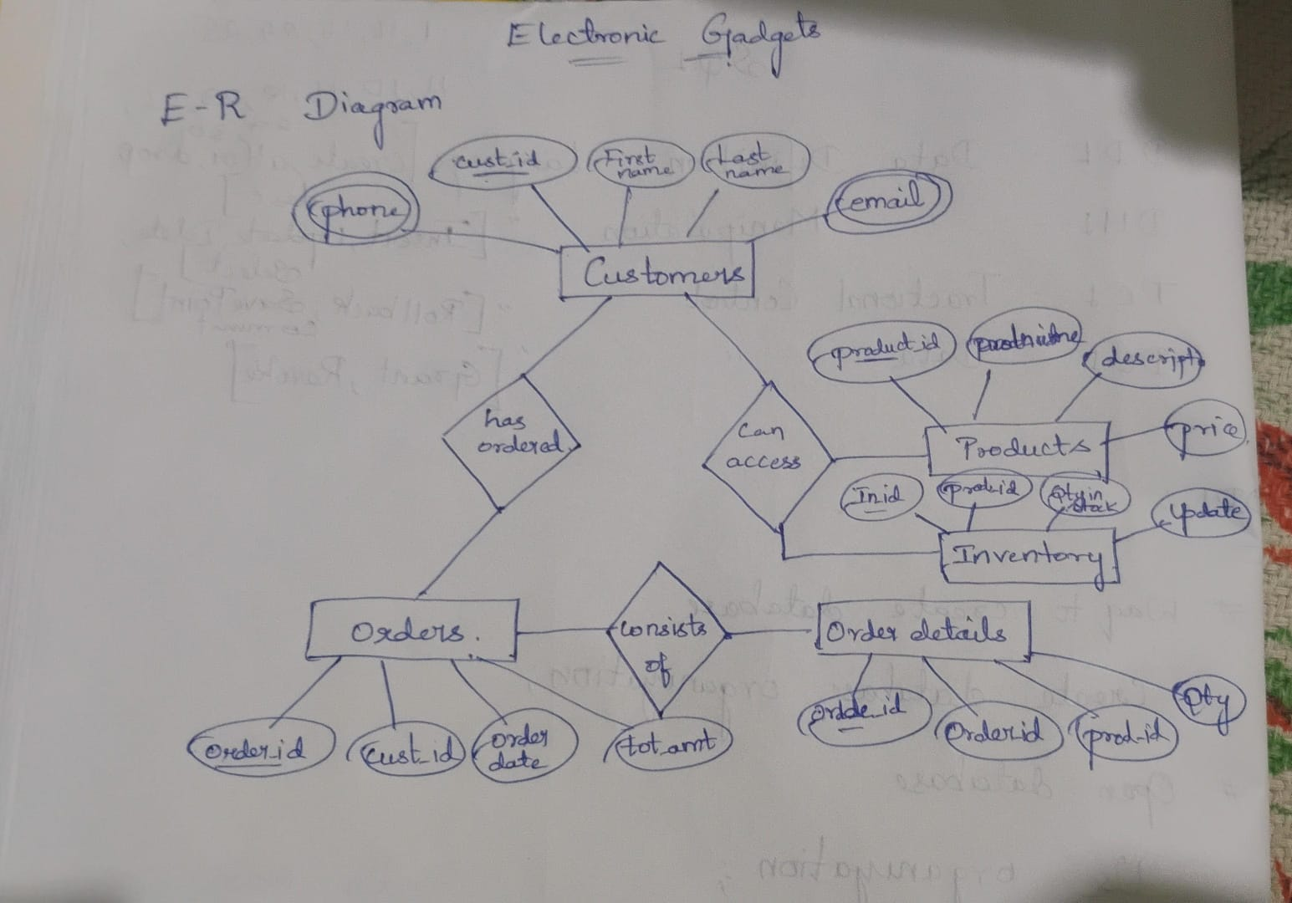

**CREATION OF TABLES:**

create table customers (customerid int primary key, firstname varchar(50), lastname varchar(50), email varchar(35), phone varchar(20), address varchar(50));

create table products (productid int primary key, productname varchar(100), description text, price int);

create table orders (orderid int primary key, customerid int, orderdate date, totalamount int, foreign key (customerid) references customers(customerid));

create table orderdetails (orderdetailid int primary key, orderid int, productid int, quantity int, foreign key (orderid) references orders(orderid), foreign key (productid) references products(productid));

create table inventory (inventoryid int primary key, productid int, quantityinstock int, laststockupdate date, foreign key (productid) references products(productid));

**INSERTION OF VALUES:**

insert into customers (customerid, firstname, lastname, email, phone, address) values

(11, 'Ethan', 'Lewis', 'ethanl@example.com', '7778889999', '753 Sycamore St'),

(12, 'Sophia', 'Hall', 'sophiah@example.com', '2223334444', '951 Poplar St'),

(13, 'Mason', 'Allen', 'masona@example.com', '8889990000', '357 Chestnut St'),

(14, 'Isabella', 'Young', 'isabellay@example.com', '5556667777', '159 Fir St'),

(15, 'Alexander', 'Scott', 'alexs@example.com', '1110002222', '357 Redwood St'),

(16, 'Mia', 'Green', 'miag@example.com', '6665554444', '753 Spruce St'),

(17, 'Benjamin', 'Adams', 'benjamina@example.com', '3334445555', '159 Elm St'),

(18, 'Charlotte', 'Baker', 'charlotteb@example.com', '9998887777', '951 Magnolia St'),

(19, 'Lucas', 'Gonzalez', 'lucasg@example.com', '4443332222', '357 Oakwood St'),

(20, 'Amelia', 'Perez', 'ameliap@example.com', '1112229999', '753 Willow St');

insert into products (productid, productname, description, price) values

(11, 'USB Flash Drive', '64GB USB flash drive', 25),

(12, 'Webcam', 'HD webcam for video calls', 70),

(13, 'Wireless Charger', 'Fast wireless charger', 40),

(14, 'Graphics Card', 'High-performance graphics card', 500),

(15, 'Motherboard', 'Gaming motherboard', 300),

(16, 'Processor', 'Latest-gen processor', 400),

(17, 'RAM', '16GB DDR4 RAM', 120),

(18, 'Power Bank', '10000mAh power bank', 50),

(19, 'Smart TV', '4K Smart TV', 900),

(20, 'VR Headset', 'Virtual reality headset', 350);

insert into orders (orderid, customerid, orderdate, totalamount) values

(11, 11, '2025-03-11', 25),

(12, 12, '2025-03-12', 70),

(13, 13, '2025-03-13', 40),

(14, 14, '2025-03-14', 500),

(15, 15, '2025-03-15', 300),

(16, 16, '2025-03-16', 400),

(17, 17, '2025-03-17', 120),

(18, 18, '2025-03-18', 50),

(19, 19, '2025-03-19', 900),

(20, 20, '2025-03-20', 350);

insert into orderdetails (orderdetailid, orderid, productid, quantity) values

(11, 11, 11, 1),

(12, 12, 12, 1),

(13, 13, 13, 1),

(14, 14, 14, 1),

(15, 15, 15, 1),

(16, 16, 16, 1),

(17, 17, 17, 1),

(18, 18, 18, 1),

(19, 19, 19, 1),

(20, 20, 20, 1);

insert into inventory (inventoryid, productid, quantityinstock, laststockupdate) values

(11, 11, 55, '2025-02-18'),

(12, 12, 65, '2025-02-17'),

(13, 13, 75, '2025-02-16'),

(14, 14, 85, '2025-02-15'),

(15, 15, 95, '2025-02-14'),

(16, 16, 100, '2025-02-13'),

(17, 17, 110, '2025-02-12'),

(18, 18, 120, '2025-02-11'),

(19, 19, 130, '2025-02-10'),

(20, 20, 140, '2025-02-09');

**TASK 2 :**

1. RETRIEVE NAMES AND EMAILS OF ALL CUSTOMERS

select concat(firstname, ' ', lastname) as name, email from customers;

2. LIST ALL ORDERS WITH ORDER DATES AND CORRESPONDING CUSTOMER NAMES

select o.orderid, o.orderdate, c.firstname, c.lastname from orders o join customers c on o.customerid = c.customerid;

3. INSERT A NEW CUSTOMER INTO THE "CUSTOMERS" TABLE

insert into customers (customerid, firstname, lastname, email, phone, address) values (21, 'helen', 'keller', 'helen@gmail.com', '75555677', '324 oakland');

4. INCREASE ALL PRODUCT PRICES BY 10%

update products set price = price + (price * 0.10);

5. DELETE A SPECIFIC ORDER AND ITS ASSOCIATED ORDER DETAILS

delete from orderdetails where orderid = 11; delete from orders where orderid = 11;

6. INSERT A NEW ORDER INTO THE "ORDERS" TABLE

insert into orders (orderid, customerid, orderdate, totalamount) values (21, 21, '2025-04-01', 450);

7. UPDATE CUSTOMER CONTACT INFORMATION

update customers set email = 'johny@example.com', phone = '2134567890' where customerid = 11;

8. RECALCULATE AND UPDATE TOTAL COST OF EACH ORDER

update orders o set totalamount = (select sum(od.quantity * p.price) from orderdetails od join products p on od.productid = p.productid where od.orderid = o.orderid);

9. DELETE ALL ORDERS AND ASSOCIATED ORDER DETAILS FOR A SPECIFIC CUSTOMER

delete from orderdetails where orderid in (select orderid from orders where customerid = 1); delete from orders where customerid = 1;

10. INSERT A NEW ELECTRONIC GADGET INTO THE "PRODUCTS" TABLE

insert into products values (11, 'usb flash drive', '64gb usb flash drive', 25);

11. UPDATE ORDER STATUS FROM "PENDING" TO "SHIPPED"

update orders set status = 'shipped' where status = 'pending';

12. UPDATE CUSTOMER ORDER COUNT BASED ON THE NUMBER OF ORDERS

update customers c set order_count = (select count(o.orderid) from orders o where o.customerid = c.customerid);

**TASK 3 :**

1. RETRIEVE A LIST OF ALL ORDERS ALONG WITH CUSTOMER INFORMATION

select * from orders o join customers c on o.customerid = c.customerid;

2. FIND THE TOTAL REVENUE GENERATED BY EACH ELECTRONIC GADGET PRODUCT

select sum(price), productname from products group by productname;

3. LIST ALL CUSTOMERS WHO HAVE MADE AT LEAST ONE PURCHASE

select * from customers where order_count >= 1;

4. FIND THE MOST POPULAR ELECTRONIC GADGET (HIGHEST TOTAL QUANTITY ORDERED)

select productname, quantity_ordered from products order by quantity_ordered desc limit 1;

5. RETRIEVE A LIST OF ELECTRONIC GADGETS ALONG WITH THEIR CORRESPONDING CATEGORIES

select productname, category from products;

6. CALCULATE THE AVERAGE ORDER VALUE FOR EACH CUSTOMER

select concat(c.firstname, ' ', c.lastname) as name, avg(o.totalamount) as average from customers c join orders o on c.customerid = o.customerid group by c.customerid;

7. FIND THE ORDER WITH THE HIGHEST TOTAL REVENUE

select o.orderid, c.customerid, c.firstname, c.lastname, c.email, o.totalamount as total_revenue from orders o join customers c on o.customerid = c.customerid order by o.totalamount desc limit 1;

8. LIST ELECTRONIC GADGETS AND THE NUMBER OF TIMES EACH PRODUCT HAS BEEN ORDERED

select p.productname, count(od.productid) as order_count from products p join orderdetails od on p.productid = od.productid group by p.productid, p.productname;

9. FIND CUSTOMERS WHO HAVE PURCHASED A SPECIFIC ELECTRONIC GADGET PRODUCT

select distinct c.customerid, c.firstname, c.lastname, c.email from customers c join orders o on c.customerid = o.customerid join orderdetails od on o.orderid = od.orderid join products p on od.productid = p.productid where p.productname = 'wireless charger';

10. CALCULATE THE TOTAL REVENUE GENERATED BY ALL ORDERS PLACED WITHIN A SPECIFIC TIME PERIOD

select sum(totalamount) from orders where orderdate between '2025-03-15' and '2025-03-17';

**TASK 4:**

1. FIND CUSTOMERS WHO HAVE NOT PLACED ANY ORDERS

select c.customerid, c.firstname, c.lastname, c.email from customers c left join orders o on c.customerid = o.customerid where o.orderid is null;

2. FIND THE TOTAL NUMBER OF PRODUCTS AVAILABLE FOR SALE

select count(quantityinstock) from inventory;

3. CALCULATE THE TOTAL REVENUE GENERATED BY TECHSHOP

select sum(totalamount) as total_revenue from orders;

4. CALCULATE THE AVERAGE QUANTITY ORDERED FOR PRODUCTS IN A SPECIFIC CATEGORY

select avg(od.quantity) as average_quantity from orderdetails od join products p on od.productid = p.productid where p.category = 'components';

5. CALCULATE THE TOTAL REVENUE GENERATED BY A SPECIFIC CUSTOMER

select max(o.totalamount) from orders o join customers c on o.customerid = c.customerid where c.customerid = 20;

6. FIND THE CUSTOMERS WHO HAVE PLACED THE MOST ORDERS

select concat(c.firstname, ' ', c.lastname) as name, count(o.orderid) as order_count from customers c join orders o on c.customerid = o.customerid group by c.customerid, c.firstname, c.lastname order by order_count desc limit 1;

7. FIND THE MOST ORDERED PRODUCT CATEGORY

select p.category, sum(od.quantity) as total_quantity_ordered from orderdetails od join products p on od.productid = p.productid group by p.category order by total_quantity_ordered desc limit 1;

8. FIND THE CUSTOMER WHO HAS SPENT THE MOST MONEY ON PURCHASES

select c.customerid, c.firstname, c.lastname, sum(p.price * od.quantity) as total_spent from customers c join orders o on c.customerid = o.customerid join orderdetails od on o.orderid = od.orderid join products p on od.productid = p.productid group by c.customerid, c.firstname, c.lastname order by total_spent desc limit 1;

9. CALCULATE THE AVERAGE ORDER VALUE ACROSS ALL ORDERS

select avg(totalamount) as average_order_value from orders;

10. FIND THE CUSTOMERS WHO HAVE PLACED THE HIGHEST NUMBER OF ORDERS

select c.customerid, c.firstname, c.lastname, count(o.orderid) as order_count from customers c join orders o on c.customerid = o.customerid group by c.customerid order by order_count desc;